UNITED STATES
SECURITIES AND EXCHANGE COMMISSION
Washington, D.C. 20549
SCHEDULE 14A
Proxy Statement Pursuant to Section 14(a) of the Securities
Exchange Act of 1934

Filed by the Registrant x
Filed by a Party other than the Registrant o

Check the appropriate box:
o Preliminary Proxy Statement
o Confidential, for Use of the Commission Only (as permitted by Rule 14a-6(e)(2))
o Definitive Proxy Statement
x Definitive Additional Materials
o Soliciting Material Pursuant to §240.14a-12
NMI Holdings, Inc.
(Name of Registrant as Specified In Its Charter)
(Name of Person(s) Filing Proxy Statement, if other than the Registrant)

Payment of Filing Fee (Check the appropriate box):
x No fee required.
o Fee paid previously with preliminary materials.
o Fee computed on table in exhibit required by Item 25(b) per Exchange Act Rules 14a-6(i)(1) and 0-11.

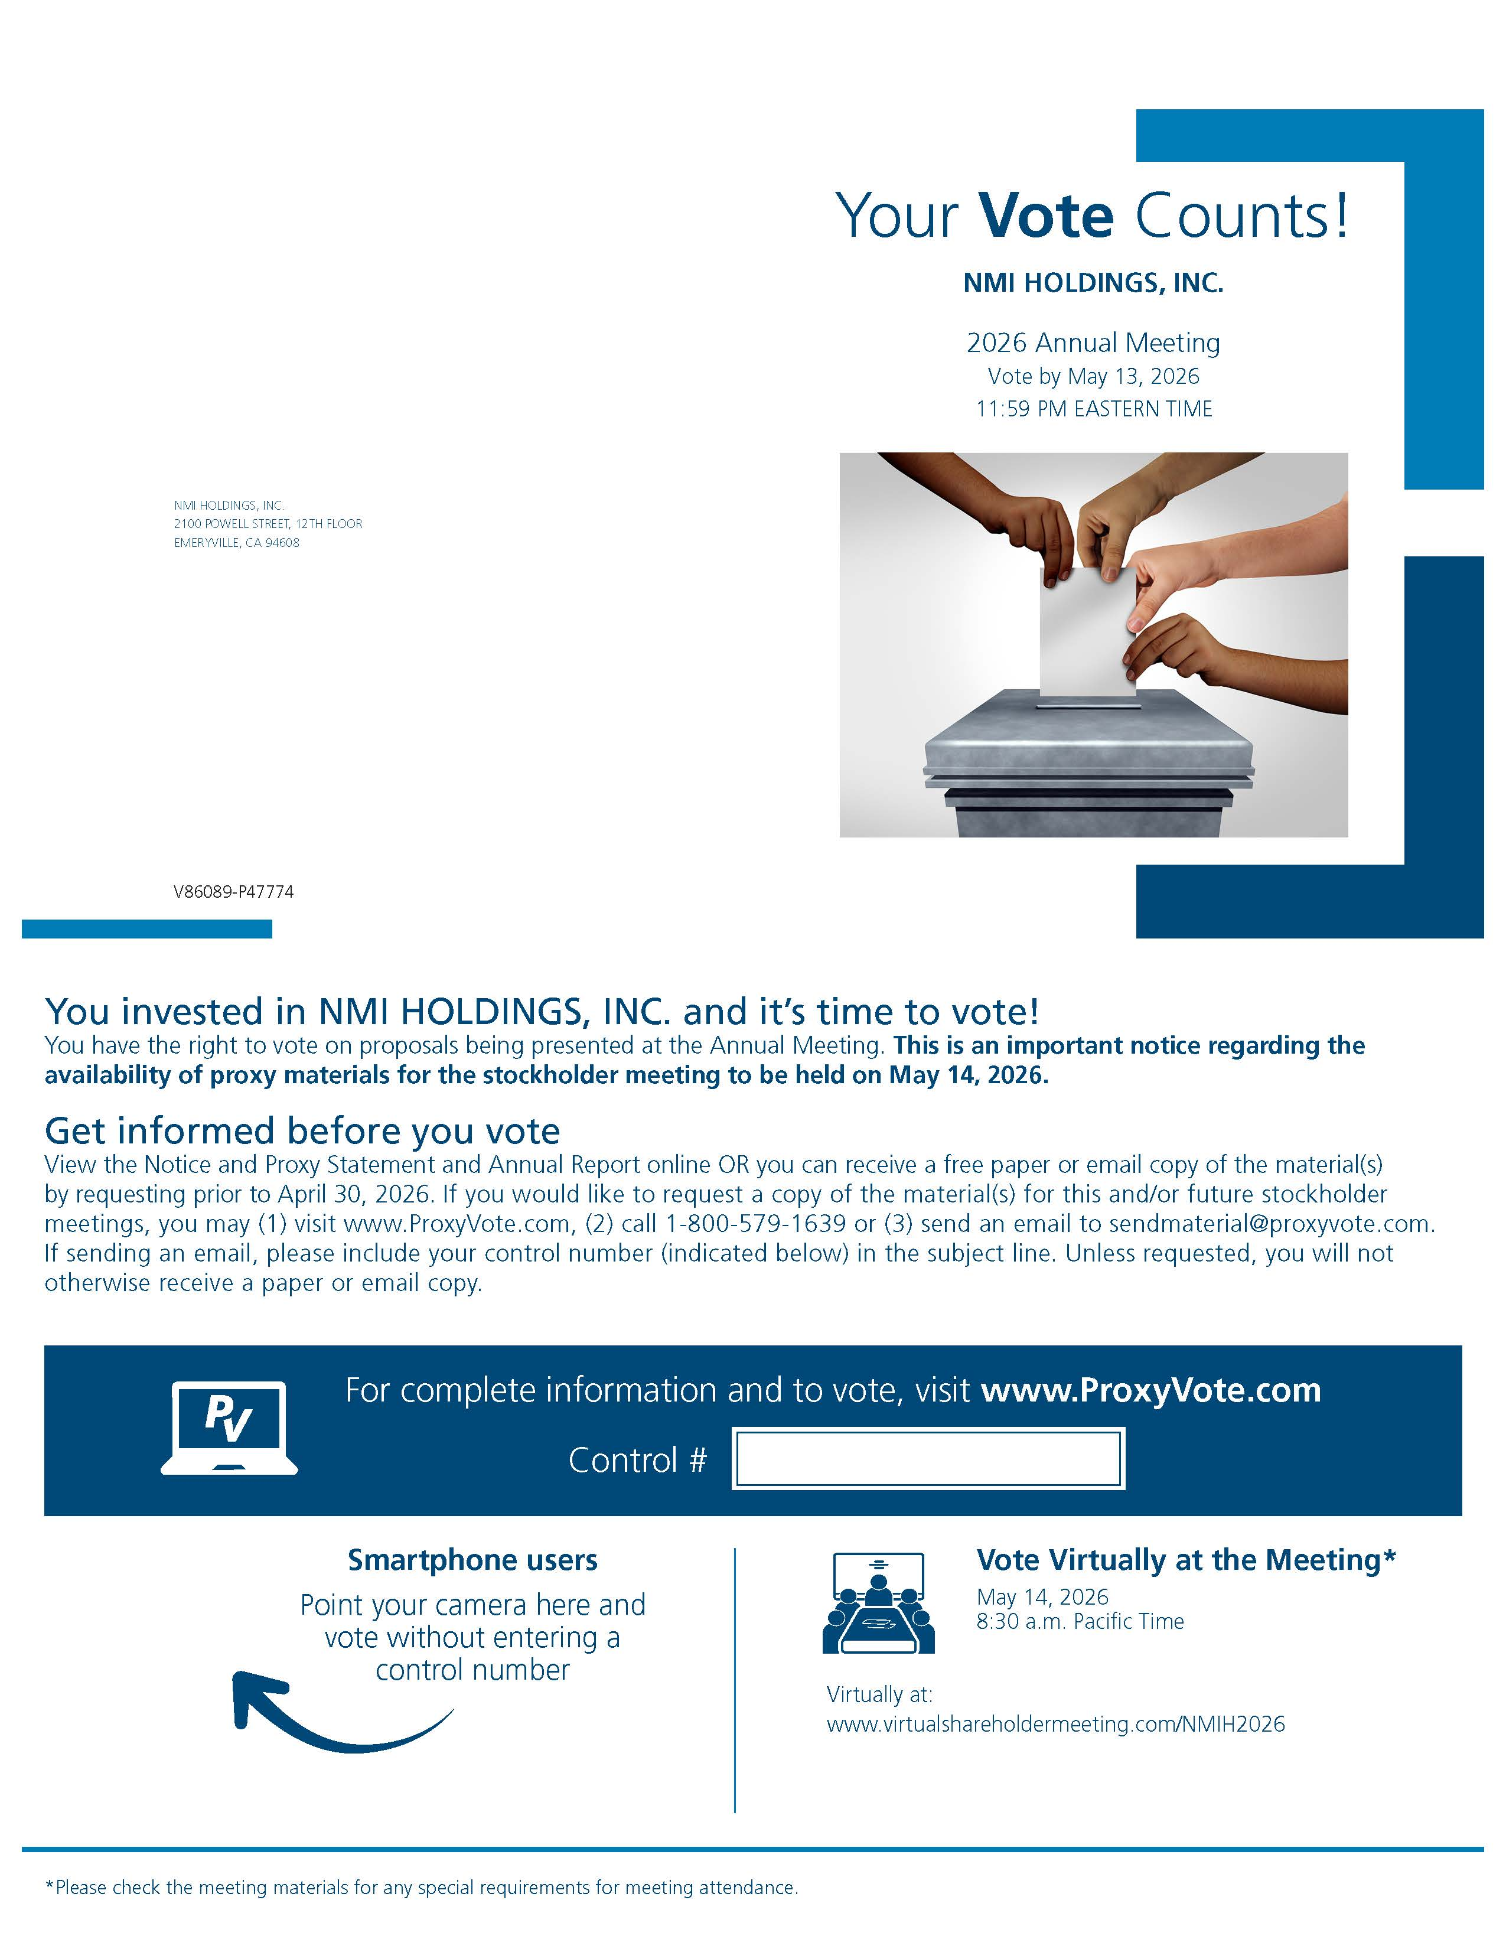
2

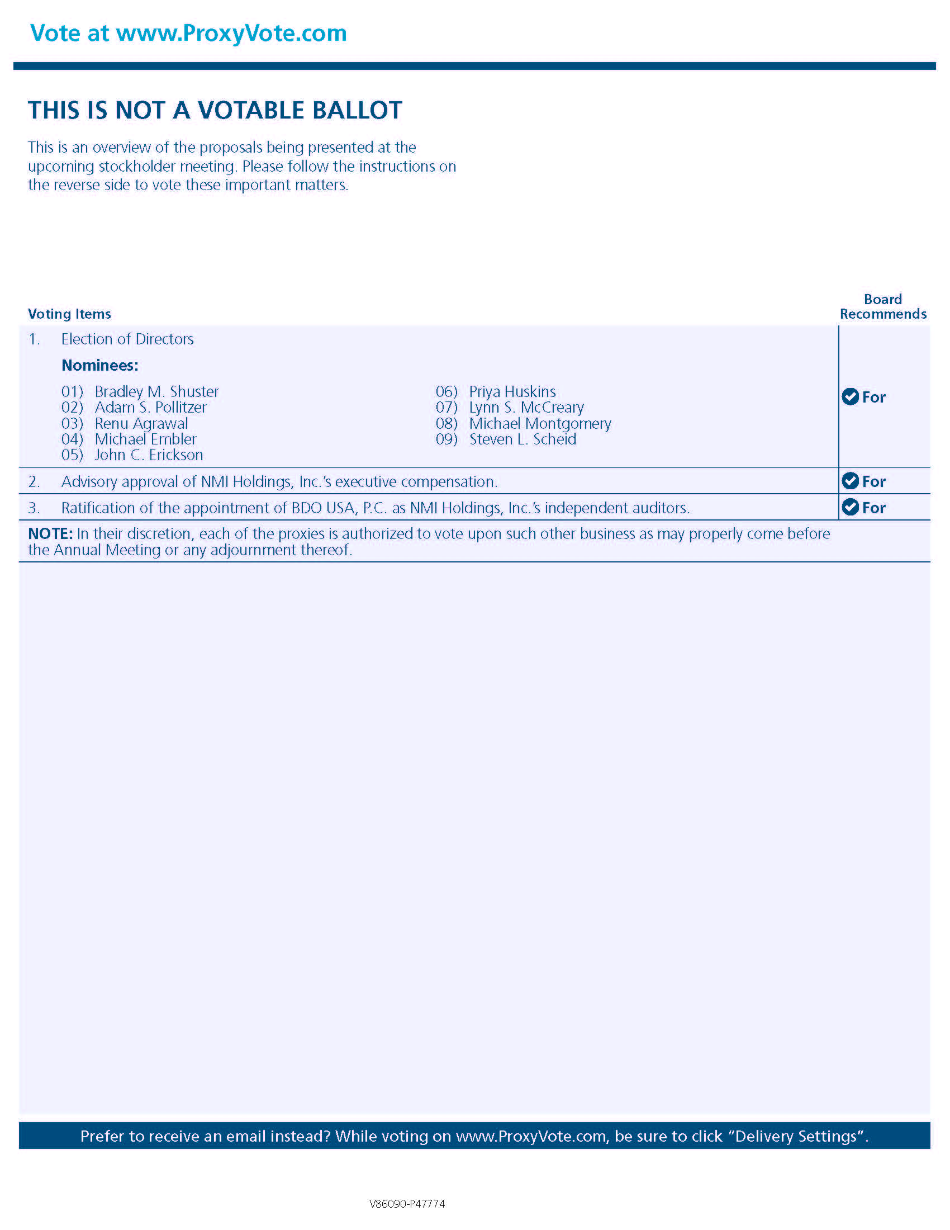
3

